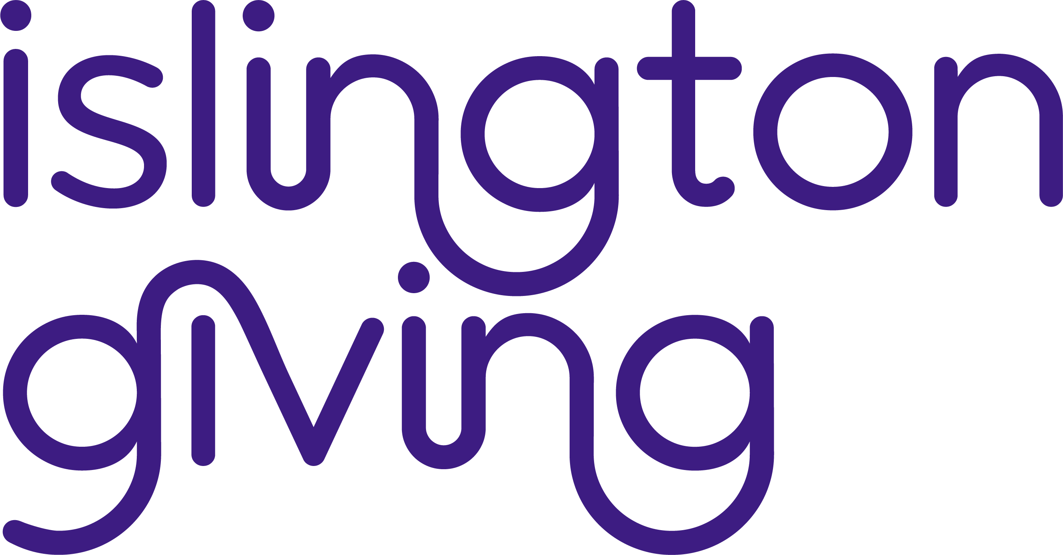

A call for project proposals by Islington Giving’s Young Grant-Makers

Application Guidelines

As the 2021 Young Grant Makers, we have been having lots of conversations about the issues that face us as young people, as we want to fund projects that benefit young people in the best way possible. We see ourselves in each other – if one person is down, everyone is down. We are a community and we want to lift everyone.

There are so many issues facing us as young people. We have spoken about poverty, inequality and cuts to services. We’ve spoken about how boredom and a lack of support is at the root of a lot of issues. Home-life is key to the opportunities open to young people: whether it’s stable or not; whether it’s encouraging or not; whether there is money or not. We also know that how a young person feels about school and/or college can change their future: does it feel ok to be at school or not; are teachers supportive and interesting; do the subjects interest everyone? We’ve also had conversations around what safety looks like for different people – including knife crime, assault, harassment and racism. We’ve spoken about how young people might lack trust in authorities and many people don’t expect much from young people or give us opportunities.

As a result of our discussions, we believe it is important that young people have safe spaces to spend time in and have the power to change the narrative around our own lives.

We are inviting applications from projects that help young people get a picture of what success means for them, and then gives them the right support to get what they need in order to realise their own, individual potential.
These could include projects that:
- Help young people transition out of lockdown, and particularly supporting mental health.
- Develop young people’s life skills to help us at transition points – such as between school and college, college and university, or into work.
- Develop young people’s skills around fields they’re interested in so they can take the next step in their careers.
- Give young people interesting things to do, and the chance to explore their talents, do things they enjoy, or try something new - particularly around creativity, arts, and language skills.

The deadline for applications is 9am on Monday 10th May

What we are looking for – our criteria
- Projects must be free
- Projects must primarily engage with children and young people aged 11-26. Your project may target particular age groups within that range.
- Projects should make sure it represents a range of people from different backgrounds and personalities.
- Projects should provide a safe welcoming environment for participants. This should include compassionate staff who can provide a safe space for young people to seek support around whatever might be going on in their lives.
- Projects should have zero-tolerance around any form of discrimination.
- You should demonstrate that the project allows young people to have a say in the project production and a say and some control over the project.
- You should demonstrate that you are able to reach young people to market your project.

We have £70,000 to distribute. We will consider applications of any amount up to a maximum of £20,000, and projects can be multi-year.

Who can apply?
To be eligible to apply:
- Charities/constituted community groups must have a management committee of at least 3 unpaid and unrelated people who have ultimate responsibility for the organisation and its finances
- Charitable Incorporated Organisations, Community Interest Companies or Social Enterprises must have a management committee of at least 3 unrelated directors who have ultimate responsibility for the organisation and its finances
- Your organisation must have a governing document or constitution
- Your organisation must have a bank account
- Your organisation must have a safeguarding policy

Islington Giving prioritises supporting voluntary and community sector groups based in Islington. However, we are also interested in hearing from groups based out of the Borough which are able to provide high-quality activities for Islington’s young people. If you are based out of the borough you will need to demonstrate that you have local knowledge and local links. All decisions will be made on a case-by-case basis.

Please note that the programme will not fund:
- Statutory services
- Services that are not free at the point of access
- Advancement of religion and religious groups, unless they offer non-religious activities and support to the local community
- Commercial or for-profit activities
- Work that has already taken place.

How to apply
Please make a full online application: https://www.tfaforms.com/4705224

This will ask specific questions, for example about how you aim to deliver the project including your approach, how you have identified the need, and how you will evidence its progress and success. It also asks for a budget, which needs to be well-thought through. Please give us as details about your project such as what you plan to do, how long for, what outcomes you’re hoping for, and be explicit about how you meet the criteria.

We would like applications to be written very clearly and straight to the point. Please make sure you make it clear what your most important points are and use simple sentence structures. The applications are being read by young people, without previous experience of looking at applications so please bear that in mind and avoid jargon and abbreviations.

As part of our assessment process, we will aim to meet a shortlist of applicants, along with an Islington Giving programme staff member, to discuss your project in more detail, follow up on any points of clarification, and ensure we have a full understanding of all the elements of your proposal. This meeting maybe virtual or in person, as regulations allow. As Islington Giving’s Young Grant-Makers we make all the final decisions on which grants to award.
Decision-making timeline
- Applications should be submitted by Monday 10th May, at 9am.
- Applicants will be informed of decisions to award grants by Friday 23rd July.

The deadline for applications is 9am on Monday 10th May.

If Your Application is Successful
Once you have been notified of the Young Grant-Makers’ decision to fund your project you will be sent Islington Giving’s terms and conditions – which you will be required to read and sign.

Full details of our requirements for feedback from your project will be agreed following confirmation of a successful application. Funded organisations will be required to keep financial records of how the grant is spent and to provide feedback on progress and learning every 12 months and when the project comes to an end.

Successful organisations will also be asked to provide publicly accessible examples of their work (e.g. case studies, photographs, blog posts) and must be willing to act as ambassadors and supporters of the Islington Giving campaign, with imaginative ideas for how this can be achieved.

Contact
You can also contact Anne Shewring (Programme Director at Islington Giving) on our behalf to ask questions about the call: T: 020 7288 6947, E: anne.shewring@cripplegate.org.uk

Background to Islington Giving’s Young Grant-Makers programme
In the summer of 2015 Islington Giving commissioned a consultation with Islington’s young people to inform our strategy for investing in Young People: Making the Most of Free Time. One of the findings from the consultation was that young people said they would like to be included in decisions about how funding is allocated for projects aimed at benefiting them. Islington Giving was serious about acting on this and giving power to young people through grant-making. The first group of young grant-makers came together between May and December 2018 and distributed £80,000 of Islington Giving’s grants budget to 7 local projects working with young people. In March, 2021, we started working with our fourth group of young people.
About Islington Giving
Islington is a borough of stark contrasts – a place where great wealth sits alongside hidden poverty. Islington Giving was set up in 2010 to address these issues and create opportunities for people in Islington. It is a partnership that brings together residents, businesses, community organisations and funders to make a real difference in the Borough.

Islington Giving currently supports over 40 local projects across 3 core themes:

- Investing in Young People
- Supporting Families
- Reaching Isolated People

Please see the Islington Giving website www.islingtongiving.org.uk for further details of our work.

