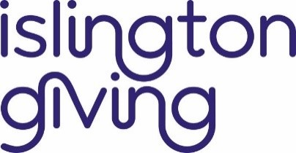

Young Grant Makers Programme – Islington Giving

`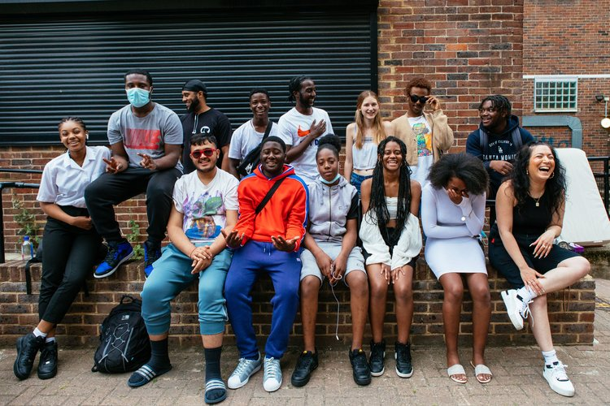

About Islington Giving:

We raise funds, give grants, and share power to support people and projects in Islington. We work closely with inspiring local organisations to address poverty and inequality.

About the Young Grant Makers’ Programme:

One of the ways in which we share power with local people is through our Young Grant Makers’ Programme. Each year we recruit 12 young people from Islington, aged 17-24, and provide support and training to enable them to decide how the charity’s money is spent to support services for young people in Islington. For example, in 2021, our Young Grant Makers decided to fund 6 projects for Young People including a Film club and festival, a community garden project, a theatre project, amongst others.

Job Description

Position | Young Grant Maker
Length of contract | Five months
Hours | 2 hours a week, plus occasional additional hours for community visits and reading as required
Pay | £11.05 per hour (London Living Wage)
Location | 13 Elliott’s Place, Islington, N1 8HX
Availability | One evening per week, plus additional time on occasion
Responsible to | Young Grant Makers’ Programme Leader
Purpose | To work as a team with other Young Grant Makers and to decide what is important to Young People in Islington, to assess community groups who are interested in applying and deciding how the money is spent.
Closing Date for Applications | 4th September, 10am
Start date | From 3rd of October

Principal Tasks & Responsibilities

- Attend a weekly two hour meeting in which you will receive support and training to become a Grant Maker
- As a team, decide what is important to Young People in Islington, and what services or activities you would want to fund.
- To create content to raise awareness of the programme and the available funding.
- To read applications and interview those who apply for funding.
- To decide how the money is spent and award funding to the successful groups!
Expectations:

- Commit to attend a weekly two hour meeting, taking place on a weekday evening at our office in Angel. There is a possibility that meetings may move online should there be Covid-19 restrictions in future.
- Reach out to the Programme leader should you require additional support.
- Work as a team; listening and being open to discuss and challenge.
- Bring ideas for what is important to you and other young people in Islington, and what you would want to change.
- Support and assist in any necessary fundraising and publicity
- Act in a professional manner while representing Islington Giving ie. Arrive on time, give reasonable notice if you cannot attend any meetings
Person Specification
Essential

- Willingness and ability to work as part of a group.
- Ability to think about and discuss what affects your local community.
- Computer skills, specifically with email and reading documents (grant applications)
- Understanding of your communities needs.

How to Apply

There are two ways to apply:

- Fill out this short form;
- Send us an email with a video or written answers to the below questions to Laura Guy at: laura.guy@cripplegate.org.uk

1. What do you like about living in Islington?
2. What issues are facing Young People in Islington?
3. If you could pick three things to improve for Young People in Islington what would they be?
4. Why do you want to be part of a programme that gives Young People power to shape their local area?
Please also provide your full name, date of birth, contact phone number, and address.
We want to make the programme as accessible as possible, and we can discuss any support you may need at any point during the recruitment process. If you have any questions and/or would like to have an informal chat about the role, please email Laura Guy: laura.guy@cripplegate.org.uk or call 07985 289407. We look forward to hearing from you.

