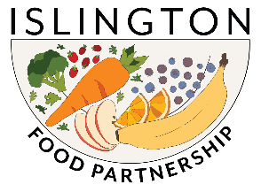

Islington Food Fund – Round 2
Application Form 2023

ABOUT YOUR ORGANISATION

1. Organisation name and address:

2. Lead contact:  Name:  Position in the organisation: | Tel:  Email:

ABOUT YOUR PROJECT
3. Project Title:

4. Project Summary (max 100 words)

5. Project overview, to include:
- Goals of the project.
- How the project will be delivered.
- Who the project will benefit.
- The themes, priorities and/or projects within the Islington Food Strategy 2023-2028 that your project aims to contribute to.
- How you intend to measure the outcomes of your project.

YOUR PROJECT BUDGET

6. Cost of your project (Please attach a copy of your budget).

7. Is there any other information you would like to provide?

Data and monitoring
We will agree a data and monitoring approach with successful applicants, based on the information you provide in your application.

Completed forms to be returned to Victor Momodu: victor.momodu@cripplegate.org.uk

