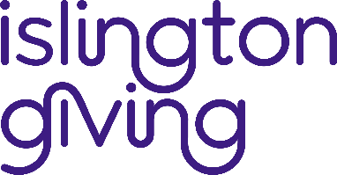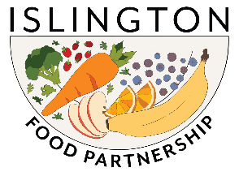

Islington Food Fund – Round 3
Application Form 2024

ABOUT YOUR ORGANISATION

1. Organisation name and address:

2. Lead contact:  Name:  Position in the organisation: | Tel:  Email:

ABOUT YOUR PROJECT
3. Project Title:

4. Project Summary (max 100 words)

5. Project overview, to include:
- Aims and goal of the project.
- How the project will be delivered and locations.
- Who the project will benefit.
- The themes, priorities and/or projects within the Islington Food Strategy 2023-2028 that your project aims to contribute to. We are particularly interested in addressing the following areas in the food strategy:
- Identify opportunities to build communal kitchen capacity across the borough.
- Develop a mechanism to support uptake and maintenance of food cooperatives in the borough.
- We are also interested in work that helps combat food insecurity for young people. This may include offering opportunities for young people to access and prepare food.
- What the anticipated outcomes of the project are - linked to your goals.
- How you intend to measure the outcomes.

YOUR PROJECT BUDGET

6. Cost of your project (Please attach a copy of your budget).

7. Is there any other information you would like to provide?

Supporting documents
- Please attach your annual accounts for the most recent year.
- Please confirm you are registered with Islington Council Environmental Health and have achieved a minimum level 3 rating.

We will be in touch if we need any additional information.

Data and monitoring
We will be requesting a half and full-year monitoring report for your project, if you are successful. This will focus on the objectives, activities, and outcomes you provide in your application.

Signed: Date:

Completed forms to be returned to Victor Momodu: victor.momodu@cripplegate.org.uk

