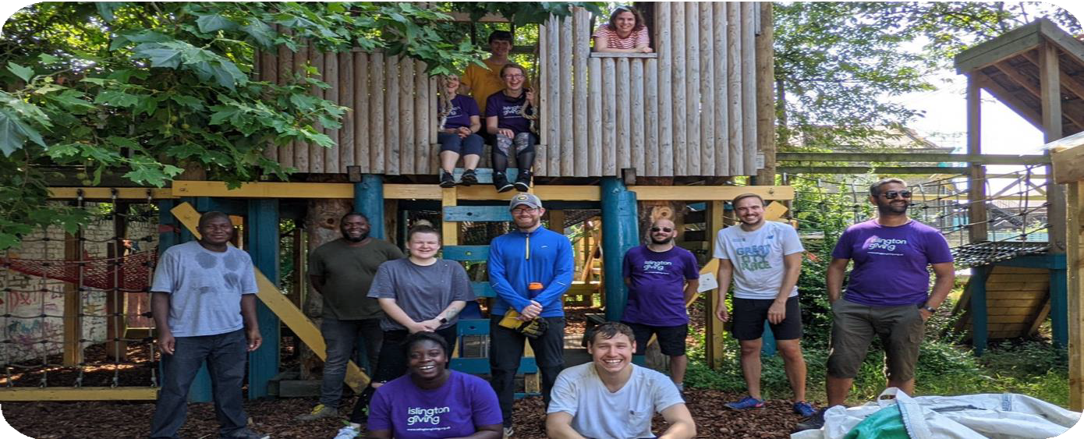

Make It Happen Coordinator – Candidate Information Pack

Please find enclosed:
- About the role and about you
- Terms & Conditions
- References
- Equalities Monitoring form
- Recruitment process
- More information about Cripplegate Foundation and Islington Giving

For further information on Cripplegate Foundation and Islington Giving please go to
www.cripplegate.org and www.islingtongiving.org.uk
Programme Requirements
The Make It Happen Fund
The Make It Happen Fund is one of Islington Giving’s grant giving programmes. In partnership with several housing associations (Peabody, Hyde Housing, Southern Housing and Clarion), we offer grants of up to £500 for groups of residents or small, local organisations who want to organise something fun in their community, to bring neighbours together, or to smarten up the area in which they live. The grants aim to give residents the power to make small changes for and with their community. Since the Make It Happen fund started in 2021, we have made 68 grants to tiny organisations and groups of residents. The fund has supported a whole range of activity, including community gardening and arts projects, Christmas and Jubilee parties, benches, paddle boarding on the canal, festivals celebrating African cultures, yoga and tai chi, community football groups, activities in care homes, play sessions, warm spaces, and a campaign to have more public toilets in Islington. Residents complete a short application form and grant decisions are made by a panel, including local residents and our funding partners.
For more information about the Make it Happen Fund and some of the groups and activity we have funded, please take a look at the Make it Happen pages on the Islington Giving website.
Description
We are looking for a coordinator to run our Make It Happen Fund.
The co-ordinator will:
- Promote the programme, using local networks, events and channels, to encourage a wide and diverse range of applicants from across Islington. This will include speaking about the fund with community groups, at events, and with individuals interested in applying.
- Support grant applicants to complete the forms and the process.
- Organise and run our decision-making meetings.
- Administer the grants once awarded.
- Produce reports for our partners on how their money has been used.
- Attend meetings with funding partners.
- Follow up with grantees to see how their project went and any follow up opportunities.

The hours will vary depending on the cycle of applications, but we would envisage the role taking one day per week on average, but with flexibility in when those hours are worked. For example, more time might be required around application deadlines and panel decisions, and the hours can be spread over a week.
Reporting will be to one of our Programme Managers who has been leading on the programme to this point.

What skills and experience do you need to apply?
We will be interested in your application if you have some of the following skills and experiences. It’s ok if you haven’t done all these things.
- Grant making within Islington. This might be through one of Islington Giving’s resident led grant giving panels or through your experience of seeking grants.
- Knowledge of community activities in Islington. You may have been involved in a local activity yourself. We’re interested in hearing about that.
- The role will involve promoting Make It Happen to community groups. Would you be confident to talk with groups about the fund? Do you have experience of this kind of interaction?
- You will need to give advice to residents wanting to apply. Many applicants have never applied for a grant before, so you will need to be able to explain the process and have patience with people wanting to apply.
- You need to have good administration skills. We receive around 20 applications each round. These need to be read, recorded and distributed to grant panel members. You will need to use our Salesforce data base to record donations. We can train you to do this, but you will need to be organised and be able to meet deadlines.
- Ideally, you will be an Islington resident. We are happy to hear from people who have been out of the job market for a while.
We are looking for someone who had take up the roll as soon as possible.

We value diversity, equality, and inclusivity. Applications are especially welcomed from underrepresented backgrounds, including but not limited to gender, race, age, sexual orientation, disability, and religion. Please let us know if you require any further support with this application, or the role.

Terms and conditions
Given the flexibility and independence of the work required, our preference is to offer this as a freelance position. This means we will pay per day/part day worked, paid monthly on receipt of an invoice. As freelance employee, you will not receive paid holiday or sick leave (or other benefits) and would be responsible for your own tax and national insurance. This is taken into account in the daily rate being offered.
We would be happy to discuss options for employment arrangements with you, and please do not let it discourage you from applying. We can discuss the employment arrangements when we meet you.
The appointment is subject to an initial six-month review, during which performance will be regularly reviewed.
Hours: One day a week, hours to be worked flexibly
Contact: This is offered as a freelance role, at £175 a day (7 hours).
Duration: We are offering this initially as a one-year contract, with extension dependant on future funding.
Reporting to: Programme Manager.
Location: Flexible with some office and remote working. There is a general expectation for working from the office for 50-60% of your working hours. The Cripplegate Foundation offices are located in the heart of Angel, Islington at 13 Elliott’s Place, Islington N1 8HX.
Training: Appropriate training will be offered and agreed with the Programme Manager.

Cripplegate Foundation and Islington Giving – Make It Happen Fund Coordinator

Application Form

Please complete the application details below.
We would also like you to answer the following three questions. If you would like to tell us anything else about yourself and why you are right for this role, please send this in an additional statement.
- Please tell us what kind of experience you have that you think would be useful in coordinating the Make It Happen Fund. This might be as a member of one of our resident-led grant making panels. We’re also interested in hearing about any other community involvement you have.
- We think the Make It Happen Fund is important in developing communities. Can you outline why you think this fund is important? What three things might you talk about when speaking to a group of residents about the programme?
- You will need to be able to organise your work, including managing the flow of applications and grants. Can you tell us about experience you have had in prioritising and administering a workload?
Please send your application to recruitment@cripplegate.org.uk by 5pm on Wednesday May 1st. If you require any further information or you would like to discuss anything in more detail, please contact Calliope Nova at calliope.nova@islingtongivign.org.uk or patrick.jones@islingtongiving.org.uk or ring 0207 288 6940. Also, if you need support to complete this application, please let us know.
After the closing date, we will invite some candidates for an interview at our offices, probably during on 7th or 8th May.

Application form
Full name
Address
Mobile phone
Home phone
Email
How did you hear of this opportunity?
Are you eligible to work in the UK?
Please give details of two professional referees. If you haven’t been in employment for a while, please give us the name of someone else who would be able to give you a reference. This could be a friend or someone who you have worked with in a project or group you have attended:
Details required | Is this your current/most recent employer | Is this a previous employer | Is this another contact
Name
Relationship to you
Telephone
Email
Ok to approach?

Depending on the projects you undertake, we may require you to have a DBS check. If we invite you for interview, we will discuss this at that point.

Declaration
I declare that the information that I have provided on this form is true and accurate, and in particular that I have not omitted any fact which may have a bearing on my application. I understand that any subsequent contract with Cripplegate Foundation and Islington Giving will be made on the basis of the information I have provided. I understand that a false declaration, which results in my appointment to Cripplegate Foundation and Islington Giving, will render me liable to dismissal without notice. I also understand that submitting this form electronically is equivalent to a signed declaration.
Signature [type your name]: Date:

Equal Opportunities Monitoring Form
Strictly confidential

To help us ensure that our equal opportunities policy is being carried out please complete all parts of this form. The information given will be kept strictly confidential and only for monitoring purposes. It will not be used as part of the selection process and is optional.

Opportunity applied for: Advertised where?

1. Gender: What is your gender?
Female [ ] Male [ ] Intersex [ ] Non-binary [ ] Prefer not to say [ ]
If you prefer to use your own term, please specify here: ______________

2. Disability: A disabled person, under the Equality Act 2010, has a physical or mental impairment that has a substantial and long-term adverse effect on their ability to carry out normal day-to-day activities. Do you consider yourself to have a disability?
Please put an x the appropriate box.
Yes [ ] No [ ] Prefer not to say [ ]
If you answered ‘Yes’ please describe the nature of your disability:

This information is requested for monitoring purposes only – if you need any reasonable adjustments you should arrange these separately.

3. Sexuality: What is your sexual orientation?
Heterosexual [ ] Gay [ ] Lesbian [ ] Bisexual [ ] Prefer not to say [ ]
If you prefer to use your own term, please specify here: ______________

4. Age: Please put an x the appropriate box
Under 25 [ ] | 25–34 [ ] | 35–44 [ ] | 45–54 [ ] | Over 55[ ]

5. Ethnic group: Please put an x in the appropriate box to indicate your ethnic background. (Categories taken from 2011 census).
Asian or  Asian British | Black or  Black British | White | Mixed | Other ethnic group
[ ] Bangladeshi  [ ] Chinese  [ ] Indian  [ ] Pakistani  [ ] Other Asian background, please specify: | [ ] African  [ ] Caribbean  [ ] Other Black background, please specify: | [ ] British  [ ] Irish  [ ] Gypsy/  Traveller  [ ] Other White background, please specify: | [ ] White/Black Caribbean  [ ] White/Black African  [ ] White/Asian  [ ] Other Mixed background, please specify: | [ ] Arab  [ ] Other ethnic group, please specify:
Thank you for completing this form. It will be filed separately from your application.

About Us
Cripplegate Foundation is a local grant-making foundation supporting residents and groups working in the London Borough of Islington and a small area of the City of London. Our vision is of a society where everyone has the opportunity to live a rewarding and fulfilled life, free from poverty and inequality.
Islington Giving was launched in September 2010, pioneering new ways of raising money and bringing much needed resources into Islington. Islington Giving brings together a coalition of local, regional, and national funders, residents, businesses, and voluntary organisations to tackle stubborn issues of poverty and inequality. Islington Giving works with, not for, residents and together we invest in young people, support families, and reach isolated people.
Across Cripplegate Foundation and Islington Giving we make grants of approximately £1.7m-£2m a year from the income from our endowment and on behalf of others.
Our Programme Team, including this role, work across Cripplegate Foundation and Islington Giving.
Cripplegate Foundation and Islington Giving have a small passionate and talented staff team. Cripplegate Foundation is overseen by 15 Governors (trustee equivalent) who make a huge contribution to our success, and Islington Giving has its own board which includes representatives from leading coalition partners. Cripplegate Foundation provides operational support to Islington Giving and manages its resources and programmes, including fundraising.
Our Vision
Our vision for Islington is of an equal society where everyone can enjoy a life free from poverty and rich in opportunities.
Our Mission
We aim to address inequality in our area of benefit. We want to improve access to opportunities for everyone and make lasting change. We do this by:
- listening to, and learning from, local people and communities,
- raising funds and making grants, and
- working in partnership with local people and organisations.
As a place-based funder, Cripplegate Foundation and Islington Giving operates in a defined geographical area. We get to know local groups well and we listen to and work with local people and organisations to identify needs and opportunities in the community and to seek out ways we can best respond. We meet most organisations which apply for funding, and regularly visit grant funded projects. We give advice on project development, other sources of funding, and local networks, and we bring organisations and residents together to share ideas and develop new initiatives. We learn from the grants we give and contribute to wider policy debate about the issues affecting residents and the actions that make a difference. We champion unpopular causes and use our independence to test new approaches to tackling poverty and inequality.
We promote a ‘relational approach’ to our work and how we partner with other organisations. You can read more about this work, developed in conjunction with local organisations through our HowNotWhat project.
With our approach, Cripplegate Foundation and Islington Giving have become leaders in place-based funding. We place a high value on working in partnership including with residents. Islington Giving’s resident-led giving has become a core element of our model.
You can find out more about our work and our recent funding programmes at www.cripplegate.org and www.islingtongiving.org.uk

